



C:\Users\stantonl\AppData\Local\Microsoft\Windows\Temporary Internet Files\Content.Word\Strapline_CMYK.JPG   
Livewell Southwest is a Community Interest Company (CIC).   
Company Registration Number 07584107. Registered in England and Wales.   
Registered Office Local Care Centre, 200 Mount Gould Road, Plymouth. PL4 7PY.

Carers Pack

Advice and support for friends and family

Do you provide help and support, on a regular basis to a partner, family member or friend with a mental illness or substance misuse?

This role is which is often referred to as ‘a carer’ but not everyone would refer to themselves in this way. The name is not important, but you are.

We would like to support you in your role while person is under our care.

We recognise that you have knowledge that could help improve that person’s treatment and care. Likewise, you may need information and support yourself.

[](https://images.pexels.com/photos/265702/pexels-photo-265702.jpeg?cs=srgb&dl=black-and-white-child-connected-265702.jpg&fm=jpg)We aim to establish a Triangle of Care in order to improve communication and support with all involved by establishing a 3 way relationship. An essential first step in the Triangle of Care is to recognise significant friends, family and carers as soon as possible.

With your consent, we will recognise you as a ‘carer’ in our electronic record system (SystmOne). This will allow us to link you and the cared for person together within the system. This will ensure that all staff aware of your relationship with the cared for person and thus keep you involved and supported throughout their care.

Your information will remain confidential at all times. A member of the team will be in contact shortly after admission to establish a relationship between yourselves and the unit, so we can learn about you, your needs and your role in recovery. Carers are entitled by law to a Carer’s assessment of what they need in connection with the mental health care of a relative or friend which is carried out by Adult Social Care. This can link to other benefits including finance. Ask the staff to make the arrangements for you to have a Carer’s Assessment. It will involve a conversation with a worker and help you both to get a clearer picture of your caring responsibilities. It is then easier to see what help is needed.

About this booklet

The following should give you some more information about your loved ones admission, and the plan for their continued recovery, whilst also showing you options for your own support in a carers role. This will be provided in conjuncture with the general information booklet. We want you to feel as supported as possible during this often distressing or emotional time, and we hope this helps clarify what to expect from your relatives stay at Cotehele Unit. If you have any other questions, please let us know and we will be happy to help.

This booklet should be thought of as having two sections – one on who you are caring for, and one on supporting your own well-being within your role. Whilst your loved one’s health is why we are here, your health is just as important.

Contents

Carer’s Guide on what to expect 4

Meet the team 4

Useful information about your role in treatment 7

Support for Carers at Cotehele Unit 11

Caring for Carers 12

Heads Count 16

Useful Websites 17

Triangle of Care 18

Carers Survey 19

Support Group 23

Carer’s Guide on what to expect at Cotehele Unit

We at Cotehele use the Care Programme Approach to treatment and recovery. We believe it is important that a person receives the right care that **the individual needs**. To provide it we need to understand the patients needs clearly, and the best way to do this is for them to join with us in planning their own care. Often it will feel right that family or close friends should be invited to help with this. Please note that you are invited to discuss anything with any member of our Multi-Disciplinary Team. If you would like more information on medication and side effects, please ask to speak to our pharmacist. If you would like to know what your loved one has been enjoying in group therapy, this can be something that our O.T. team can help with. The below information will hopefully give you an idea of what your loved one can expect, and who they will be interacting with whilst at Cotehele.

Meet the Team at Cotehele Unit

Nursing Team

The expert nursing team at Cotehele is made up of our Health Care Assistants, Registered Mental Health Nurses, our Nurse-In-Charge and our Modern Matron. The Care Coordinator for the inpatient is part of this team; though if he/she is unavailable, our other members of staff will be compassionate, knowledgeable and eager to help with any concerns or queries. You will see the Care Coordinator in MDT ward rounds, and everyone else in the team around the unit. Please see our staff board to see who’s who.

Consultant Psychiatrist & Junior Doctors

The consultant and doctors will be there for your loved-one in regards to your immediate treatment. It is important to let them know if you are have concerns with symptoms or medication, as they are best equipped to help you. This can be discussed at ward round each week.

Occupational Therapy

Our occupational therapy team do daily group work with each patient, participation being greatly encouraged as part of their care plan. Each group is geared around reflection, empowerment and personal growth. Some groups also exercise the body as well as the mind, with attention paid to getting even our least mobile patients engaged.

[](https://images.pexels.com/photos/707194/pexels-photo-707194.jpeg?cs=srgb&dl=cacti-gardening-grow-707194.jpg&fm=jpg)If a patient has a particular therapeutic activity in mind for the unit, they can contact the O.T to see if this can be facilitated, as part of their individual care plan.

Another facet of O.T is assessing the home for any needs you may have to help someone function better at home. The age group at Cotehele may for example need to make some adjustments within their home for ease of life – this could be a bath lift, an elevated toilet or some handrails. The aim is to be safe as well as independent at home.

Support Time Recovery Workers

An STR Worker will provide **support** and give **time** to the patient and thus promote their **recovery.**

The focus of the STR worker at Cotehele is to help the patient plan for a successful discharge in a variety of ways. The STR will be involved from admission to discharge to help set goals of recovery, help to identify any practical needs of the patient and to facilitate a variety of opportunities and activities to empower the patients self-esteem, self-worth and independent needs.

STR Workers also work closely with friends, family and carers to ensure they are part of recovery and get any information or support that they may also need as part of their role in your life, and keeping them up to date.

Physiotherapy

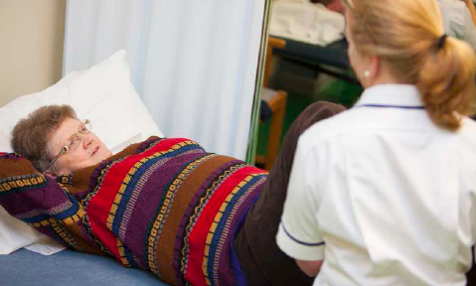If the nursing team identify any mobility issues they will refer to Physio team.

They will make every effort to assist patients in maintaining their independence with mobility in as safe a way as possible, by empowering the patients and showing them safe ways to gain that independence with their mobility again.

Pharmacists

Our pharmacist is always available to discuss medication – any information about concerns, side effects or even how it works.

Non-Clinical Staff

Our ward clerk will always be based in the central office and is there to help staff with the administration and organisation of running a hospital. They are very friendly and will always be able to point you in the right direction with a smile.

Our team in hotel services are responsible for maintaining high standards of cleanliness throughout the unit. The team are fully trained, regularly updating their skills to enable them to operate within national guidelines. They use tried, tested and approved cost effective cleaning materials at all times.

The team also provide the patients’ meals, serving a balanced and nutritional meal three times daily. They also ensure that patients have access to snacks and hot drinks throughout the day. All dietary needs are catered for and every effort is made to vary the menu on a regular basis. They will also point you to our Cotehele Café Corner.

Useful information about your role in treatment

General

We ask you to be involved in treatment as you are usually the person who will know our patient best. You will be able to recognise unusual behaviour, escalating symptoms or medication side effects. You are a vital part in making sure that we have a full and robust treatment plan. The following information may answer some questions you have about the part you may play.

Confidentiality

* The staff may say that your relative has told them not to talk to you. Don’t take this too personally – it is not unusual when people are mentally distressed for them to become very suspicious, especially about those closest. This won’t stop you being told general things about how the ward functions or being supported yourself but be prepared that is a difficult issue for staff as well, as we want our rapport with the patients to be strong.
* The triangle of care is of course a three way relationship. We have a promise to uphold with our patients that what they share with us is confidential. We will need to get your loved ones permission before we can share information with you.
* The information that you provide us is also confidential. What you share with us in regards to your loved ones treatment plan is something we hope to share between members of staff as to keep them updated. If you share something personal with us, this is confidential, though we would like to inform other members of staff of the action points of the meeting. For example, if you mentioned to a staff member in confidence that you were struggling with finances due to caring responsibilities, it would be fed back to explain “have referred to carers trust”. If you didn’t feel comfortable doing this, please let us know.

Leave

* Please ensure you have spoken to a Nurse about your own safety plan and that of your loved one when you take them out on leave.
* If the staff talk about ‘letting your relative have some leave off the ward’, do make sure that your views are heard especially if their home is with you and they intend to eventually return.
* Don’t cancel any important plans – your own needs are very important – insist on being informed in good time to allow proper arrangements to be made.
* If your relative is here on an informal basis, day trips without supervision from a member of staff is of course up to the patient. However, if the staff feel that this would be detrimental to the health and safety of the patient, we would try and discuss this with the patient and advise them accordingly. If the patient still wants to leave in spite of the risks we have warned them of, we may have to section them under the Mental Health Act (1983) for their protection. If your relative is here under a formal section, leave is still possible from the ward. This is called Section 17 leave, and will be given only by the Consultant Psychiatrist. If you would like more information on the Mental Health Act (1983), please let us know.

Ward Round

A Ward Round review is held weekly, please speak to a member of staff if you wish to attend a Ward Round as there is a process to get booked in. Alternatively you are welcome to phone prior to, or after the meeting to provide information or have an update. Remember that you are entitled to a copy of the care plan if your loved one gives permission for you to receive one.

Feedback

After leave from the ward find a way to feed your experiences – including any questions and problems back to the staff. You can mention side effects, concerns and what went well. It would be a great help if you were to complete the carer’s survey at the end of your loved one’s stay, so we can improve on our methods. Doing so will also get you a chocolate from the office as a thank you!

Discharge

If your relative is being discharged to your home you should be involved when the Discharge/Care Plan is being drawn up. The meeting should be clear about what community services are needed to keep your relative well. It should agree what signs may point to a developing relapse and the actions to be taken, contact details and keep the phone number carefully. If you don’t feel you have had all this information, please ask.

Future Planning

It is important for staff and yourself to encourage your relative to agree to make an Advance Statement and sign it. This will set out a series of actions agreed to when they were well which they wish to be followed. Copies should be kept by several parts of the service, as well as by yourself. A copy of the Advanced Statement is given to your relative in their welcome pack, and will be completed by discharge.

Some example questions to ask the team

We work to ensure that all families and carers receive the support and information needed, but appreciate you may need guidance on asking the right questions about the person you are caring for. It is hard to think on the spur of the moment about everything you might want to know, especially in a time that may be stressful or upsetting to you. Please do remember that you can ask for a copy of your loved ones care plan (with their permission of course).

Although you may not want to ask all the questions listed, you may find that they help you in preparing to meet the mental health team and to get your needs met.

About the illness

* What is the diagnosis or problem?
* Why has this happened to them?
* Will they recover?
* Where can I get written information about this disorder?

About the assessment

* What are the types of assessments you do on an assessment ward?

Care Program Approach (CPA)

* What is the CPA?

About care and treatment

* What is your plan for treatment?
* What are the aims of the care and treatment?
* How long will they need the treatment or be on the ward?
* What happens if they refuse treatment?
* What is a care co-ordinator?

Medication

* What medication is to be used and how?
* Why have you chosen this particular medication?
* What symptoms might mean that the dose should be changed?
* What are the possible side effects of this medication?
* What should I do if they experience unpleasant side effects?

My Needs

* Am I a carer?
* I understand that as a carer I am entitled to an assessment and care plan of my own. Who should I speak to?
* If I have a specific need of my own, who should I ask?



At Cotehele Unit we are proud to a part of the Triangle of Care. We believe that your voice, plus the professionals and the voice of the patient combined will give the best possible outcome for recovery. If you have any questions about this, please ask. A poster is included with this pack.

Finally…

It is very important that you try to keep your own life – especially when you first become involved in someone’s care. The rest of this booklet aims to help you find ways to ensure you stay happy and healthy.



Support for Carers at Cotehele

Every Thursday at Cotehele we have dedicated time for family, friends and relatives to pop in and get guidance, support and information on treatment and community support. Friendly members of staff will be available for an informal chat and a coffee, and may be able to signpost you to other services or advise on next steps for recovery. They may also be able to help with practical support such as how to apply for a blue badge, or what financial aid is available to you and the person in our care. We can also offer written information on mental illness and how this could apply to your loved one.

Please give us a call to arrange a time and we will be happy to see you.

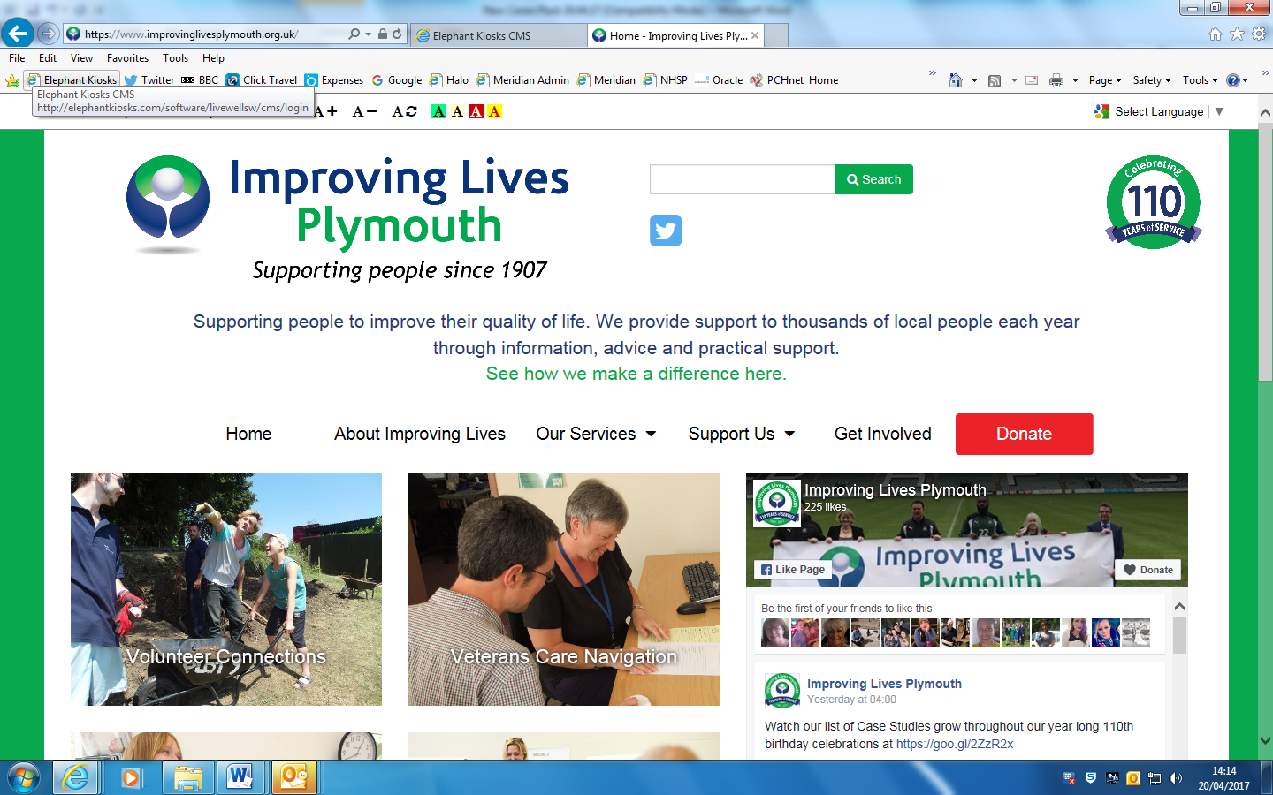

Caring for Carers

**Do you care for a friend, relative or neighbour who without your support would struggle to manage. If so, you are a Carer.**

**Carers Assessment**

From April 2015, changes to the way care and support is provided in England mean you may be eligible for support, such as a direct payment to spend on the things that make caring easier; or practical support, like arranging for someone to step in when you need a short break. Or you may prefer to be put in touch with local support groups so you have people to talk to.

The council covering the area where the person you care for lives can help you find the right support and you can ask them for a carer's assessment.

A carer's assessment will look at the different ways that caring affects your life and work out how you can carry on doing the things that are important to you and your family. Your physical, mental and emotional well-being will be at the heart of this assessment. As a result, you may be eligible for support from the council, who will also offer you advice and guidance to help you with your caring responsibilities.

You can have a carer's assessment even if the person you care for does not get any help from the council, and they will not need to be assessed.

**Carers Fund**

The carers fund is available for carers to access money to support them in the caring role. The main aim of this fund is to improve quality of life for carers, and money is awarded specifically for the purpose of carers taking time to "switch off" from their caring role.

**Carers Support Groups**

Caring for someone can often feel isolating. Support groups have been set up across the city for carers to drop in and meet and talk to other people in caring roles. This allows the opportunity to meet with others and share experiences, offer support and advice to each other. Groups are run on an informal basis with tea, coffee and biscuits provided. There is always a carers support worker who understands the difficulties carers can often face, and are there to offer support and advice.

Groups that currently run across the city are:

* Estover - Colwill Lodge Drop In Support
* City Centre - Ernest English House
* Male Carer Drop In Support Group
* Carer Drop In Support Group for Autism & Asperger’s
* Carers for Learning Disabilities Drop In Support Group
* Mannamead - Dementia Carer Drop In
* Harewood House Carer Drop In Support Group
* North Prospect Library Carer Drop In Support Group
* Plymstock Library Carers Drop In Support Group
* St Budeaux Library Carers Drop In Support Group

**Carers Card and Discount**

A Carers card offers identification of your role as a Carer, and offers a range of discounts across the city, in order for you to take some time for yourself. There are a number of discounts offered on gym memberships, beauty treatments, alternative therapies, car servicing and family activities.

**Carers Health and Wellbeing Check**

For those who are over the age of 18 you can benefit from a free and confidential health check specifically designed for carers. The check, carried out by a trained health professional, will cover your health and well-being as fully as possible and will give you a chance to discuss your physical health, emotional well-being and the challenges of caring. It also provides an opportunity to pick up on any early signs of ill health and enable you to access any necessary treatment before a crisis develops.

An added bonus is that you will be offered information and support to help you in your caring role and receive reassurance for you and the person you care for.

The following practices have signed up to this programme:

* Roborough Surgery
* Knowle House Surgery
* Church View Surgery
* Estover Surgery
* St Levan Surgery
* Mannamead Surgery
* Armada Surgery
* Chard Rd Surgery
* Adelaide Street Surgery
* Barton Surgery
* Sutherland Road Surgery
* Wycliffe Surgery
* Stoke Surgery
* Stirling Road Surgery
* Collings Park Medical Centre
* St Neots Surgery
* West Hoe Surgery
* Beaumont Villa Surgery
* Budshead Road Medical Practice
* Elm Surgery
* Friary House Surgery
* Glenside Medical Centre
* Beacon medical group - this includes Plym River Surgery, Ivybridge Health Centre, Ridgeway Surgery, Chaddlewood Surgery and Wotter Surgery
* Saltash Road Surgery
* Pathfields Practice – This includes Plympton Health Centre, Laira Surgery and Efford Medical Centre
* Lisson Grove

We understand that being a carer can be difficult. We hope that this information has helped, and provided you with some idea of what support is available for you.

You are an integral part of the care and treatment of the people we see on a daily basis. Thank you for all that you do.

If you have any questions or would like some further information, we urge you to contact Caring for Carers.

**Opening Times & Contact Details**

Monday - Friday 9.00 am - 5.00 pm

We are closed on all Bank Holidays and the week between Christmas and New Year.

**Caring for Carers  
Improving Lives Plymouth  
156 Mannamead Road  
Plymouth  
PL3 5QL**

### 01752 201890

[caringforcarers@improvinglivesplymouth.org.uk](mailto:caringforcarers@improvinglivesplymouth.org.uk)



Heads Count is a user led network for mental health service users, carers and everyone with experience of or affected by mental health matters.

We gather individuals’ views, ideas and experiences and help represent these views to service commissioners and providers, to improve mental health services for the future.

**We aim to achieve the following and more:**

Reduce negative attitudes and raise awareness about the importance of mental health and wellness.

Strive to improve community mental health support and services through active engagement & involvement.

To make mental health and wellness an inspiring & positive goal for individuals and communities.

Become a fully inclusive and diverse service.

**Heads Count is service user led and will:**

Support local people to get involved and be heard

Talk to members about what has changed as a result of their involvement

Offer support & training for people who are involved

Listen  
  
*For more information or to become a Heads Count supporter please contact us.*

*01752 261978* [*headscount@colebrooksw.org*](mailto:headscount@colebrooksw.org)

http://www.colebrooksw.org/wp-content/uploads/2013/05/facebook.jpghttp://www.colebrooksw.org/wp-content/uploads/2013/05/twitter.jpg

Jan Cutting Healthy Living Centre | Scott Business Park | Beacon Park Road | Plymouth | PL2 2PQ

|  |  |  |
| --- | --- | --- |
| Hearing Voices | [www.hearing-voices.org/](http://www.hearing-voices.org/) | Provides support for those Hearing Voices and helps to explain how this might feel |
| MIND | [www.mind.org.uk](http://www.mind.org.uk) | Information regarding Mental Health diagnosis and understanding how these might present |
| NHS Choices | [www.nhs.uk](http://www.nhs.uk) | Provides easy to understand guidance on medications and symptoms |
| Carers Trust | [www.carers.org](http://www.carers.org) | Invaluable information, support and resources for those caring for someone’s mental health problems |
| SEAP Advocacy | www.seap.org.uk/local-authority/plymouth.html | Independent mental health advocates who can provide information about patients legal rights as inpatients. |

Useful Websites

**Recognising Family, Friends and Carers of People accessing Mental Health Services**

Do you provide help and support, on a regular basis to a partner, family member or friend with a mental illness or substance misuse?

**This role is which is often referred to as ‘a carer’ but not everyone would refer to themselves in this way. The name is not important, but you are.**

**We would like to support you in your role while person is under our care.**

**We recognise that you have knowledge that could help improve that person’s treatment and care. Likewise, you may need information and support yourself.**

**We aim to establish a Triangle of Care in order to improve communication and support with all involved by establishing a 3 way relationship.**

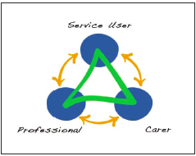

**An essential first step in the Triangle of Care is to recognise significant friends, family and carers as soon as possible.**

**With your consent, we will recognise you as a ‘carer’ in our electronic record system (SystmOne). This will allow us to link you and the cared for person together within the system. This will ensure that all staff aware of your relationship with the cared for person and thus keep you involved and supported throughout their care.**

**Your information will remain confidential at all times.**

**Please ask for further information from members of the nursing team**

**Carer’s Survey – Mental Health In-Patients Wards**

Date of Cared for Persons Admission: Today’s Date:

|  |
| --- |
|  |

Ward:

|  |
| --- |
|  |

**We would like you to think about your recent experiences of our service**

How likely are you to recommend this team/ward to other people who support a person with mental health needs?

|  |  |  |  |
| --- | --- | --- | --- |
|  | Extremely likely |  | Unlikely |
|  | Likely |  | Extremely unlikely |
|  | Neither likely nor unlikely |  | Don’t know |

Can you tell us why you gave that response?

|  |
| --- |
|  |

Do you give consent to have your comments anonymously published?

|  |  |  |  |
| --- | --- | --- | --- |
|  | Yes |  | No |

Did you receive a clear explanation of what was going to happen when the person you support was admitted?

|  |  |  |  |
| --- | --- | --- | --- |
|  | Very clear |  | Unclear |
|  | Quite clear |  | Very unclear |
|  | Neither clear nor unclear |  | Don’t know/ Not applicable |

Did you receive a Carer’s Information Pack?

|  |  |  |  |  |  |
| --- | --- | --- | --- | --- | --- |
|  | Yes |  | No |  | Don’t know |

How useful was the Carer’s Information Pack?

|  |  |  |  |
| --- | --- | --- | --- |
|  | Very useful |  | Not very useful |
|  | Quite useful |  | Of no use |
|  | Neither useful nor not useful |  | Don’t know |

To what extent have your views and knowledge been considered throughout the assessment and treatment process?

|  |  |  |  |  |  |
| --- | --- | --- | --- | --- | --- |
|  | Always |  | Sometimes |  | Don’t know |
|  | Usually |  | Never |  |  |

Have you been given enough information about the service and key people providing care (i.e. psychiatrist, named nurse, named care coordinators and carer’s champion?

|  |  |  |  |  |  |
| --- | --- | --- | --- | --- | --- |
|  | Always |  | Sometimes |  | Don’t know |
|  | Usually |  | Never |  |  |

Do you think the staff understand the needs of the person you support?

|  |  |  |  |  |  |
| --- | --- | --- | --- | --- | --- |
|  | Always |  | Sometimes |  | Don’t know |
|  | Usually |  | Never |  |  |

Have the staff offered you sufficient opportunity to talk with them and listen to your concerns?

|  |  |  |  |  |  |
| --- | --- | --- | --- | --- | --- |
|  | Always |  | Sometimes |  | Don’t know |
|  | Usually |  | Never |  |  |

Have the staff treated you with respect and kindness?

|  |  |  |  |  |  |
| --- | --- | --- | --- | --- | --- |
|  | Always |  | Sometimes |  | Don’t know |
|  | Usually |  | Never |  |  |

Have you been regularly involved and informed about care plans and treatment for the person you support?

|  |  |  |  |  |  |
| --- | --- | --- | --- | --- | --- |
|  | Always |  | Sometimes |  | Don’t know |
|  | Usually |  | Never |  |  |

Have staff explained, in a sensitive way, what information can and cannot be shared with you?

|  |  |  |  |  |  |
| --- | --- | --- | --- | --- | --- |
|  | Always |  | Sometimes |  | Don’t know |
|  | Usually |  | Never |  |  |

Do you feel confident that the person you support was safe during their stay?

|  |  |  |  |  |  |
| --- | --- | --- | --- | --- | --- |
|  | Always |  | Sometimes |  | Don’t know |
|  | Usually |  | Never |  |  |

Do you think that the person that you care about has been given enough help with their daily needs (for example, eating, washing, dressing)?

|  |  |  |  |  |  |
| --- | --- | --- | --- | --- | --- |
|  | Always |  | Sometimes |  | Don’t know |
|  | Usually |  | Never |  |  |

Have you been given enough advice and support to help you cope with the behaviour and needs of the person that you care about?

|  |  |  |  |  |  |
| --- | --- | --- | --- | --- | --- |
|  | Yes |  | No |  | Don’t know/ Not appropriate |

Have you been sufficiently involved in planning for the discharge of the person that you care about?

|  |  |  |  |  |  |
| --- | --- | --- | --- | --- | --- |
|  | Yes |  | No |  | Don’t know/ Not appropriate |

Have staff talked to you about local services that are available to support you in your caring/supporting role?

|  |  |  |  |  |  |
| --- | --- | --- | --- | --- | --- |
|  | Yes |  | No |  | Don’t know/ Not appropriate |

Additional Comments

|  |
| --- |
|  |

**About You**

What is your gender?

|  |  |  |  |  |  |  |  |
| --- | --- | --- | --- | --- | --- | --- | --- |
|  | Male |  | Female |  | Transgender |  | I’d prefer not to say |

What is your age?

|  |
| --- |
|  |

What is your ethnic group?

|  |  |  |  |
| --- | --- | --- | --- |
|  | White |  | Asian/Asian British |
|  |  |  |  |
|  | Mixed/Multiple Ethnic Groups |  | Other ethnic group |
|  | Black/African/Caribbean/Black British |  | I’d prefer not to say |

**Thank you for your time**

**Please Return to the Ward you are referring to using the envelope, or drop it in next time you are in the ward. Once you’ve let us know you’ve completed it, we will also give you a small token of thanks.**

