Eating Techniques following Weight Loss Surgery
Following weight loss surgery, the way that you eat will need to be adapted. The following recommendations will reduce complications of gastric reflux, regurgitation, pouch dilatation, oesophageal dilatation and possible band erosion if you have a gastric band..
- Before you start your meal, ensure you are sitting at a table. You also need to allow yourself 20 minutes to eat your meal.
- Avoid all distractions whilst eating. This encourages ‘Mindful Eating’
- Ensure that plate is a tea size plate. This helps prevent overeating.
- Bite sizes need to be small. No bigger than a 20 pence piece.
- Chew eat portion of food 20 times before swallowing.
- Wait for 1 minute before you take your next bite of food.
- Eat for only 20 minutes. You may find it helpful to time yourself with a kitchen timer or stop watch on your phone.
- Stop eating before 20 minutes if you start experiencing pain or discomfort in your chest. This is a common indicator that you have over eaten.
- If you have any food left on your plate at 20 minutes, throw it away immediately. Do not save it for a snack later.
- Do not drink during your meal. Drinking during your meal can cause the food to swell, causing discomfort. It also can cause trapped wind if you gulp fluids to fast causing regurgitation and pain.
- Recommendations for when to have fluids before and after a meal:
30 minutes before a meal
30 minutes - 1 Hour after a meal

- Carbonated Drinks should be avoided lifelong: Following surgery your new stomach is much smaller and therefore will struggle with carbonated drinks. This will cause you discomfort and pain in your chest, such as heart burn. Long term: drinking carbonated drinks on a regular basis and in large volumes can also cause your new stomach to stretch

- Ensure you are following the recommendations regarding food group portions. Refer to ‘Bariatric Plate’ diagram below: Daily recommendations of Protein 60-80 grams per day:

Bariatric Plate:
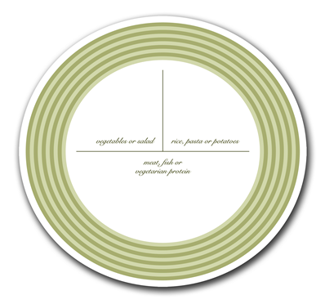
Quarter plate: Vegetables or Salad
Half Plate of a protein source:
Meat, fish, beans, lentils and pulses.
Quarter Plate:
Rice, Pasta, Potatoes

- Avoid problematic food: Common foods that can cause a problem are as follows:
Steak, Pork and Bread Products, Noodles. Some people struggle with Chicken Breast.

- Chewing Gum should also be avoided as this will stimulate your saliva and head hunger

- Remember also to take your daily multivitamin and mineral supplements.

