Am I hungry? Where is my hunger coming from?
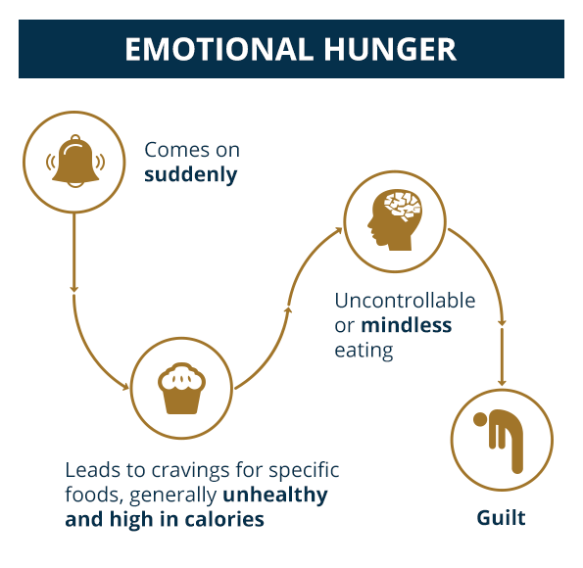

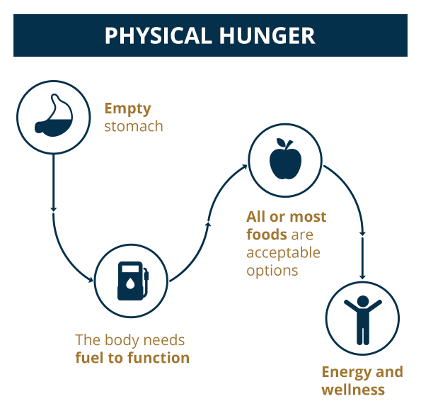

(Acknowledgement: National Eating Disorders Association (NEDA) )

