Example of front of pack label using traffic light coloured lozenges
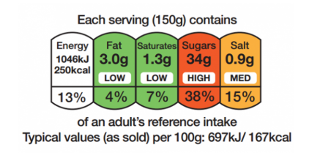
- Use the front of pack lozenges as a quick reference guide
- Look at the colour of the lozenge for FAT
- Look at the colour of the lozenge for SUGARS
- Ignore all numbers and percentages on all of the lozenges
- For more detailed information, see the Nutrition Information panel on the back or side of the pack

What do the colours of the lozenges mean?
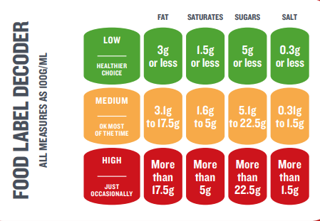
- Green = Low in fat or sugar: A healthy choice

- Amber = Medium fat or sugar content: OK most of the time

- Red = High fat or sugar: Choose these occasionally

Example of back (or side) of pack nutrition information panel

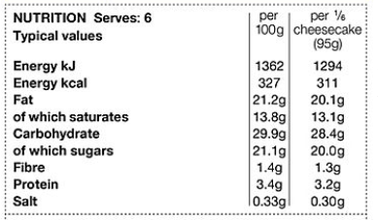
- Always use the per 100g column on the nutrition table instead of per portion / per serving etc.
- It is the easiest and most accurate way to compare different products.
- Use the Info per 100g to compare fat & sugar levels in different foods. Try to choose the product with the lowest grams of sugar and fat per 100g.
- Use the info per 100g to compare fibre levels in different foods. Try to choose the product with the most grams of fibre per 100g.

Example of an ingredients list
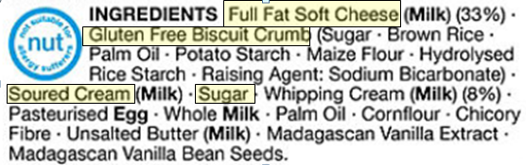
- The ingredients list helps you work out how healthy a product is.
- Ingredients are listed in order of weight, so the main ingredients in the package are always listed first. Check the first 3 or 4 ingredients to see what’s in the recipe that you are buying.
- Ingredients that appear further down the list will be added in smaller amounts, but they can still be significantly high in sugar or fat.

