 | Monday | Tuesday | Wednesday | Thursday | Friday | Saturday | Sunday
Fruit  Veg  Starchy carbs  Protein  Dairy  Fats & oils | 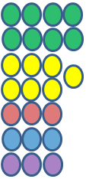
Breakfast

Snacks

Lunch

Snacks

Dinner

Evening snacks

Sugar-free Fluids
Any ‘Treat type foods’ ?

