What are my current triggers?

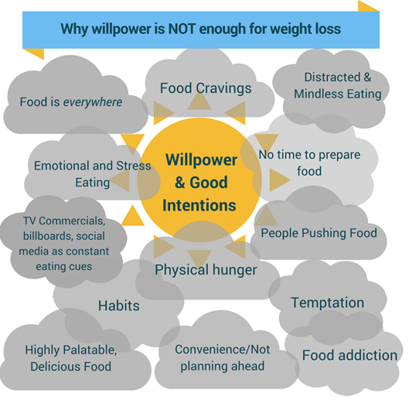
(Acknowledgement:www.freshapproachtonutrition.com)

Recognising what triggers me to eat when I am not hungry will help me to choose other ways of responding that do not involve food.

