Plymouth Online Breastfeeding Support
Below is a schedule of free online breastfeeding support being held throughout the week

There is daily breastfeeding support available for you and your babies.  If you or your baby are unwell please contact maternity triage on 01752 430200  You can also contact a Health Visitor on  01752 434008 | 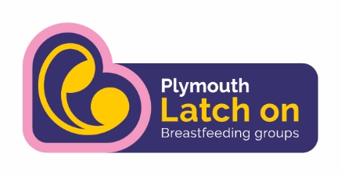  Breastfeeding Peer Support  Follow and PM  Message the Facebook page Monday and Wednesday for the zoom link for that day. Message anytime for support |  | Feed Sleep Bond  IBCLC (Lactation Consultant)  Follow and PM  Email:  lyndsey@feedsleepbond.com Call: 07764514899 |  | Email lllgb.plymouth@gmail.com  to register and receive an invite to meetings  Email llsaltash@yahoo.co.uk for 1:1 help with urgent breastfeeding concerns from an internationally accredited LLL breastfeeding counsellor at any time. |  | 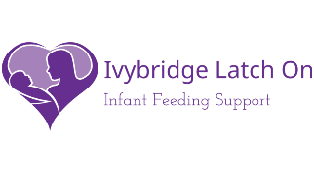  Breastfeeding Peer Support  Follow and PM
 | Group | 1:1 | Group | 1:1 | Group | 1:1 | 1:1
Mondays | 12 - 1pm  zoom | On request | Live video & Q&A on fb 2pm | On request |  | On request | On request
Tuesdays |  | On request |  | On request |  | On request | On request
Wednesdays | 1pm – 2pm  Zoom | On request | Live video on fb 2pm | On request |  | On request | On request
Thursdays |  | On request |  | On request |  | On request | On request
Fridays |  | On request | Live video on fb 2pm | On request | 11am - 12:30pm  Zoom | On request | On request
Saturdays |  | On request |  | On request |  | On request | On request
Sundays |  | On request |  | On request |  | On request | On request

