WARM UP AND STRETCHES
Aim: Try and do daily, 4 x each, hold 10-15 seconds

Warm up in sitting.  Music on, 2-3 mins | Ankle wrist circles, head turns, shoulder circles, hands on shoulders and circle elbows, arm swings, touch head, shoulders and knees, punches, arm swing around body, heel raises, marching on spot.
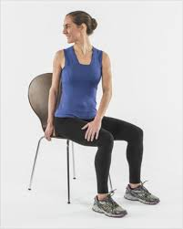 | Neck stretches  Double chins  Neck turns  Ear to shoulder.  Chin to chest. | 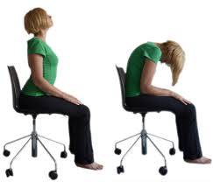 | Cat/cow  Slowly alternate between sitting tall with curve in back to slum sitting
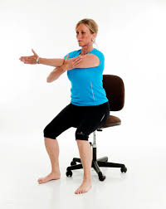 | Shoulder stretch  Take the arm across your chest and give a gentle push inwards with opposite hand | 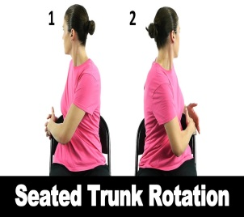 | Trunk rotation  Rotate around with trunk and head, hook elbow around chair for additional stretch
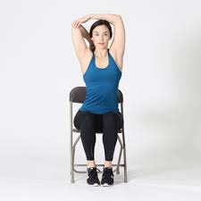 | Triceps  Take one arm up and back and reach down back, use opposite hand to apply gentle pressure down on elbow | 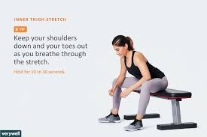 | Inner thigh  Step your legs outwards and apply gentle pressure outwards on knees for increased stretch
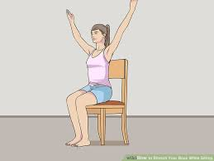 | Upper body  Sit tall and take hands from knees to V shape above | 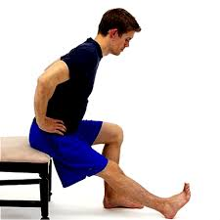 | Hamstrings  Sit on edge of chair, take one leg forward, sit tall and lean forward. You can rest the elbow on the opposite leg
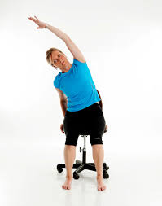 | Side stretch  Stretch alternate sides | 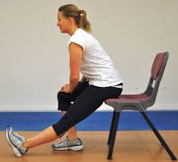 | Calf stretch  Step one leg back and push down through the knee of that leg.

