HOME CIRCUIT
Aim: try and do 2-3 x week start with 5-10 each and build up over time slowly and safely
 | Warm up and stretch beforehand as attached, | 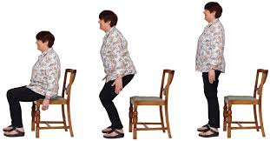 | 1. Sit to stand  Sit to stand slowly and safely using chair with arms.  Alternative: Sit and kick alternate legs up and down.
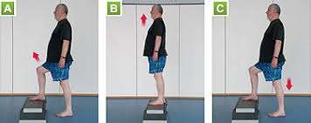 | 2. Step ups  Holding on to wall/rail if need be, step up and down.  Alternative: Toe tap up and down | 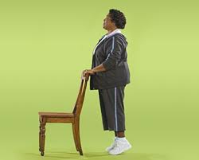 | 3. Toes  Holding on to supportive surface push up onto toes slowly.  Alternative: Do this seated.
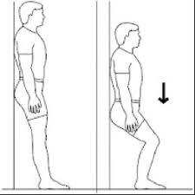 | 4. Slide  Standing with back to wall, slowly slide down and back up. Not too far. | 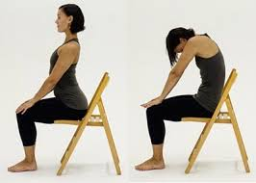 | 5.Cat/cow  Sitting slowly go from slouch to sitting tall and achieving arch in lower back
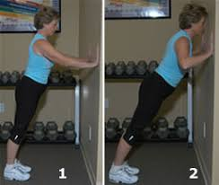 | 6.Press ups  Stand to a wall; hold your body straight, hands at shoulder height on wall for press ups.  Alternative:  Sitting press up on wall. | 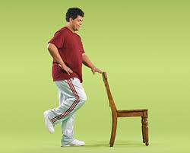 | 7.One leg  Standing at supportive surface practice standing on one leg and alternate
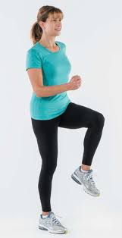 | 8.March  Standing at supportive surface march on spot  Alternative:  Seated marching |  | 9. Lifts  Standing tall holding small bottle of water/ weights lift up.  Alternative:  Punching forward

