End of Life Care Strategy 2021 – 2024.

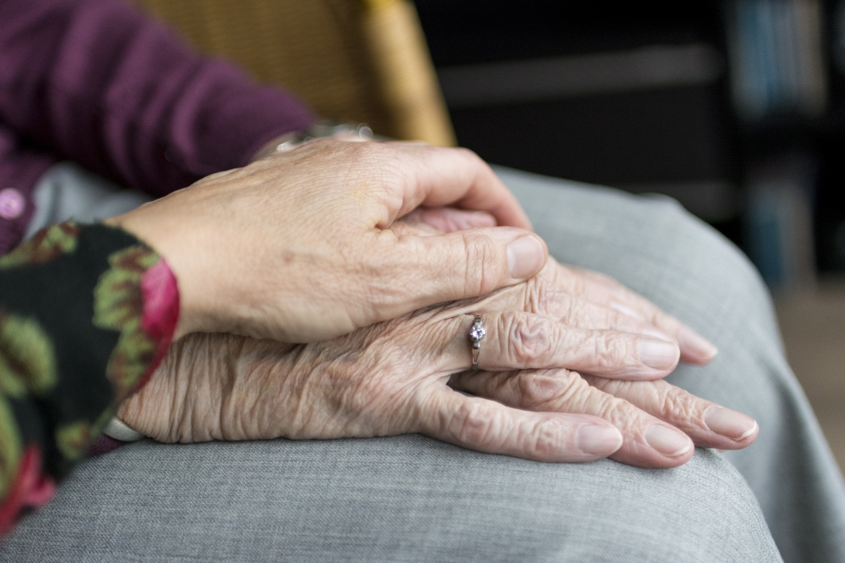

Introduction
“How we care for the dying is an indicator of how we care for all sick and vulnerable people”
(National End of Life Care Strategy 2008)
Death and dying are inevitable. The quality and accessibility of palliative care will affect us all and it is our belief is that everyone can contribute to improving End of Life Care. As an organisation providing Mental health, Physical health and Social Care service we are in a unique position to ensure we provide consistent high-quality palliative and end of life care to everyone within our sphere of influence.

We aim to promote a culture across the organisation where people are confident and supported in their ability to have open and honest discussions about dying and death. Which in turn will enable patients, their families and communities to have open and honest conversations about their wishes.

In order to provide meaning toward the end of life we will encourage patients and families to express their individual needs and wishes including spiritual and religious requirements which we will facilitate as far as is practicable.

The care we provide to the patient, families and friends extends to the period after death including support and advise immediately after someone has died as well as during the bereavement process.

Livewell Southwest is committed to provide education and training to support our staff in being confident in their decision making and are competent with the skills required for delivery of care.

As a lead provider of community, mental health and social care our End of Life Strategy reflects the requirement for all staff to have an awareness of end of life and palliative care and provides a framework based on the six ambitions, which are aligned to our values, highlighted within the Ambitions for Palliative and End of Life Care: A national framework for local action 2021-2026 (National Palliative and End of Life Care Partnership).

1. Each person is seen as an individual
2. Each person gets fair access to care
3. Maximising comfort and wellbeing
4. Care is undertaken in a coordinated way
5. All staff are prepared to care
6. Each community is prepared to help

Definitions

End of life for the purpose of this strategy is deemed to be when the patient is felt to likely have less than one year to live (Gold standard framework, Proactive Identification Guidance, 2016 Gold Standard Framework - PIG - Proactive Identification Guidance Registration Form (goldstandardsframework.org.uk) .

Who benefits from this service?

Our overall aim will be to ensure that the needs of people of all ages who are living with life limiting conditions, dying, death and bereavement, their families, carers, and communities will be addressed with dignity, taking into account their priorities, preferences and wishes. We recognise that this is something that we are unable to achieve in isolation, so working in collaboration with our partners in Health and Social Care, the Voluntary Sector and Commissioners is integral in ensuring that the ambitions are achieved.

Scope of the strategy

Although the extent to which staff will be involved with End of Life Care will vary significantly along with experience this strategy has relevance to all members of Livewell Southwest staff, from those who first encounter the patient and families to the executive board.

Staff have a responsibility to understand how their role links to individuals who may be at End of Life and to use the resources available to them to ensure they are able to fulfil their role competently and confidently. Involvement in End of Life Care can at times be emotionally stressful to staff and they should access the support available as required.

Our Ambition

We aim to provide excellent care and support to people who are dying including their families and carers. We aim to maximise the individual’s choice while helping them to stay safe and well at home or their preferred place of care.

Our Future Plans

Palliative Care and End of Life Provision

End of Life care is delivered by a broad range of health and social care providers within the Western locality of NHS Devon Clinical Commissioning Group.

Our ambition is to make palliative and end of life as good as possible for individuals and the people who are important to them, ensuring everyone works together confidently, honestly, and consistently.

In order to achieve this, we will base our strategy on the Ambitions for Palliative and End of Life Care – A National Framework for local action 2021-2026. https://acpopc.csp.org.uk/system/files/documents/2021-05/FINAL_Ambitions-for-Palliative-and-End-of-Life-Care_2nd_edition.pdf

Ambition 1 | Objectives/broad statements
Each person is seen as an individual. | - The person and the people important to them, have opportunities to have honest, informed, and timely conversations and to know that the individual might die or are approaching end of life.  Information will be provided at a time that is right for the patient and their family to enable them to make timely informed choices about their future care.  - The individual is asked what matters most to them.  - Those who care for the individual know what matters to the dying person and are facilitated to work together with Livewell staff to achieve those wishes  - Those who care for the individual are listened to and supported, their own fears and concerns are recognised  - To provide excellent End of Life Care taking into account the personal wishes of patients, families and those important to them through honest conversations about dying, death and bereavement at a time when people feel ready.  - Person centred care will be delivered in consideration of personal wishes by competent, confident staff.  - Heath and social care needs will be co-ordinated.

Future Delivery Plan:
- There will be an End of Life Champion in each appropriate service area who have skills in managing honest, well-informed conversations about dying, death and bereavement.

- All staff to have an awareness in communication skills. Level dependant on extent of involvement in End of Life Care provision.

- All staff to have awareness of bereavement care. Level dependent on extent of involvement in End of Life Care.

- All clinical staff involved in End of Life Care to be competent in breaking bad news/advanced communication skills.

- Individuals approaching the end of their life will be offered the chance to complete an advance care plan with the involvement of families if this is their wish.

- All staff to have an awareness of advance care planning. Some staff to be able to help individuals to write an advance care plan dependant on extent of involvement in End of Life Care provision.

- TEP (Treatment Escalation Plans) are completed in a timely manner by appropriate staff, and shared according to the individual’s wishes, and in line with Devon TEP Guidance. The quality of TEPs to be monitored and audited and outcomes will be fed back to service areas with an expectation that improvements will be made.

- Ensure appropriate staff are competent and confident in completion, review and implementing TEP’s.

- Appropriate staff are able to care coordinate and manage packages of care to ensure individuals are in receipt of appropriate treatment and care, and where appropriate personal health budgets are implemented

- Exploring availability of support in respect of bereavement throughout the locality. Jointly agreeing with other providers how this may be provided, to include the Livewell services and voluntary sector.

- All staff to know where to signpost for bereavement support.

Ambition 2 | Objectives/broad statements
Fair access to care | - Good end of life care is provided no matter who the individual is, where they live or the circumstances of their life

Future Delivery Plan:
- Work in partnership with other organisations within the Western Locality to develop community partnerships and a compassionate community

- Use appropriate data collection to enable us to accurately monitor and report and improve Palliative and End of Life Care delivered within our services

- Work with patients and their families and engage with the Patient Experience Manager to develop, monitor and evaluate person centred outcome measures.

- We will use this data to guide us in the development of services that improve the care we provide to the people in our communities.

- We will continue to build on the relationships we have with other healthcare providers to ease the transition of care between services and support people when they are at their most vulnerable.

Ambition 3 | Objectives/broad statements
Maximising comfort and wellbeing | - The individual’s care is regularly reviewed.  - Every effort is made for the individual to have the support, care and treatment that might be needed to help them to be as comfortable and as free from distress as possible.

Future Delivery Plan:
- We will ensure that all appropriate staff are developed and skilled in ensuring they are able to attend to the changing needs of people promptly. Physical comfort and symptom management of individuals who are palliative and end of life will be managed appropriately. In order to deliver this we will develop a comprehensive training package for Palliative and End of Life Care, with a clear competence framework, based on the End of Life Core Skills Education and Training Framework (Health Education England, Skills for Health, and Skills for Care 2017).

- We will ensure that staff are able to recognise and identify spiritual and emotional needs, and distress of the individual, carers and loved ones and support in an appropriate manner, which may include sign posting or something more direct such as a conversation or provision of a quiet space.

- We will continue to embed the use of individualised care planning to support the achievement of personal goals while maximising independence and safety throughout our organisation.

- We will work with other providers to ensure clear pathways for accessing Specialist Palliative Care including care packages.

- We will ensure that individuals have a clear understanding of how to access support, and use medication and equipment provided if a rapid response is required to meet changing needs, for example provision of Just In Case Bags and anticipatory medication.

- We will ensure that individuals have clear information provided on how to access out of hours services such as Devon Doctors or Out of Hours District Nurses.

- We will help maximising independence and social participation of the individual according to their wishes and facilitate such support as they may require to achieve this.

Ambition 4 | Objectives/broad statements
Care is coordinated | - Individuals get the right help at the right time from the right people.  - There is a team around the individual who know their needs and their plans and work together to help them achieve them.  - The individual can always reach someone who will listen and respond at any time of the day or night.

Future Delivery Plan:
- We will ensure the individual is fully involved in the development of their individualised care plan.

- We will further develop information sharing protocols to ensure care records are shared, with informed consent of the individual, appropriately with all those involved in the individual care.

- Organisation leaders are united in their ambition to ensure providers work together to deliver a joined up response to meet the needs of the individual, working with commissioners to facilitate the appropriate distribution of resources as outlined in the Strategic Transformation Plan.

- We will continue to ensure all individuals have clear information provided on how to access out of hours services such as Devon Doctors or Out of Hours District Nurses.

- Palliative care for children is not provided by Livewell however it is recognised that there is a gap in service around out of hours provision. We will work with the Western Locality providers to develop a business case to meet this need.

Ambition 5 | Objectives/broad statements
All staff are prepared to care | - Wherever the individual is, health and care staff bring empathy, skills and expertise and provide competent, confident and compassionate care.

Future Delivery Plan:
- Supporting and working with all providers of care, including carers, to have empathy, skills and expertise in providing competent, confident and compassionate care. This activity will be provided in conjunction with St Luke’s Hospice through their End of Life Forum and through Livewell Palliative and End of Life Forum.

- End of Life Champion in each appropriate service area who have skills in managing honest, well-informed conversations about dying, death and bereavement.

- Knowledge of up-to-date standards, NICE guidance and legislation will be available to all staff through our Palliative and End of Life Webpage.

- The nominated Executive Lead for End of Life is the Chief Executive Officer who will keep the Livewell Board informed of all developments.

- Operational and Professional Leadership are provided by a nominated Palliative and End of Life Care Lead and Head of service who will account to the Acting Chief Executive Officer and Director of People and Professionalism.

Ambition 6 | Objectives/broad statements
Each community is prepared to help | - Individuals live in a community where everybody recognises that we all have a role to play in supporting each other in times of crisis and loss.  - People are ready, willing and confident to have conversations about living and dying well and to support each other in emotional and practical ways.

Future Delivery Plan:
- Continue to be an integral part of the development of a compassionate community, working with other providers to develop this.

- We will deliver an annual campaign to enable the staff and the public to have an improved understanding of End of Life care provided by Livewell and the Western Locality of NHS Devon Clinical Commissioning Group.

- Support the Livewell Volunteer Co-ordinator to work alongside partner organisations including acute and primary care to develop appropriate volunteers to support people, their families and communities.

References

- Department of Health, 2008. National End of Life Care Strategy. Available on line at: https://assets.publishing.service.gov.uk/government/uploads/system/uploads/attachment_data/file/136431/End_of_life_strategy.pdf (Last accessed15/12/2021).

- The National Palliative and End of Life Care Partnership, 2021. Ambitions for Palliative and End of Life Care – A National Framework for local action 2021-2026 Available on line at: https://acpopc.csp.org.uk/system/files/documents/2021-05/FINAL_Ambitions-for-Palliative-and-End-of-Life-Care_2nd_edition.pdf / (Last Accessed 15/12/2021)

- Next Steps on the NHS Five Year Forward View, 2017. https://www.england.nhs.uk/wp-content/uploads/2017/03/NEXT-STEPS-ON-THE-NHS-FIVE-YEAR-FORWARD-VIEW.pdf (Last accessed 15/12/ 2021).

- Leadership Alliance for the Care of Dying People: One Chance to Get it Right, 2014. Available on line at: https://www.gov.uk/government/uploads/system/uploads/attachment_data/file/323188/One_chance_to_get_it_right.pdf (Last accessed 15/12/2021)

- National Institute for Health and Clinical Excellence, 2011 (updated September 2021). Quality Standard for End of Life Care for Adults Available on line at: https://www.nice.org.uk/guidance/qs13 (Last Accessed 15/12/2021)

- National Institute for Health and Clinical Excellence, 2015. Care of dying adults in the last days of life. Available on line at: https://www.nice.org.uk/guidance/ng31/resources/care-of-dying-adults-in-the-last-days-of-life-1837387324357 (Last accessed 15/12/2021)

