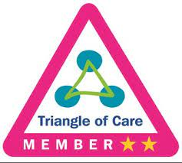

Carer Information Booklet

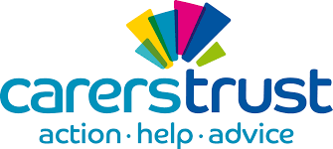
Specialist Outreach Recovery Team

Who is a Carer?
A carer is someone who, without payment, provides help and support to a friend, neighbour or relative who could not manage otherwise because of frailty, illness, or disability. This may include helping with person care, medication, cooking, shopping, housework and giving emotional support.

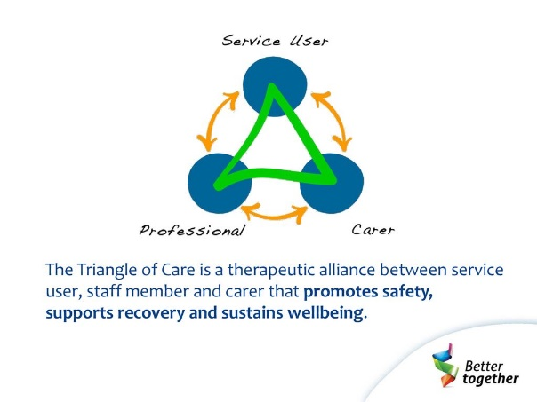
With your consent, we will record you as a ‘carer’ in the electric records of the person you care for. This will ensure that all staff aware of your relationship with the cared for person and thus keep you involved and supported throughout their care.
General Information for SORT Carers
Please make sure that staff know that you are the main carer, and they have your name and phone number on record.
Please make sure you record the following information her for you records
Care Co-ordinator__________________________________________________________
Support worker ____________________________________________________________
Your Doctor _______________________________________________________________
The Care Coordinator will work closely with your relative and the Doctor – the Staff may call them the Responsible Clinician.
The Staff may tell you that your relative has told them not to talk to you which can be upsetting. Try not to take this too personally- it is not unusual when people are mentally distressed for them to become very suspicious, especially about those closest. Legally this is something the patient can request but staff will aim to encourage positive communication and revisit this decision regularly. This won’t stop you being told general information about SORT functions or being supported yourself and is no obstacle to listening to your concerns. Please remember that this is a difficult issue for staff as well.
As a carers you are entitled by law to a Carer’s Assessment which can identify what you might need in to help you in your caring role. These can be carried out by Adult Social Care but most will be undertaken in Plymouth by Caring for Carers (please see section below)

What is the Specialist Outreach Recovery Team?
The Specialist Outreach Recovery Team (SORT) is important part of the care pathway for mental health care. This is not an emergency response service. Our aim is to make sure that, that after a diagnosis of a serious and enduring mental health problem, a treatment and support plan is designed to meet the person’s needs. It is through this process that we aim to promote independence and offer support in the local community to achieve full potential and optimal recovery wellbeing.
The Team
The Specialist Outreach Recovery Team is a multi-disciplinary. Within our team we have:
- Doctors
- Community Mental Health Nurses
- Mental Health Social Workers
- Occupational Therapists
- Psychologist
- Support Workers
- Substance Misuse Specialist
Our staff team all work together to make sure your relative/friend is fully assessed and treated for all their different needs. We also provide education and training for future NHS staff, so student nurse, student Doctors and therapists in training may be involved in the care provided.

Important Information
The Team is based at Avon House, but we complete home visits in the community.
Our Specialist Outreach Recovery Service operating times are:
Monday to Friday 9.00 am to 17.00 pm.
Please Note: If your Care Co-ordinator is not available during these times, please leave a message and they will get back to you as soon as they can.
Children Visiting
Please be mindful under 18 years old are not allowed in the building.
What happens whilst your Relative is a under our care?
Everyone supported by the Specialist Outreach Recovery Team either follows the Care Programme Approach (CPA) or Standard Care process, depending on their individual need.
When we have the consent of the person under our care, you will have the opportunity to be involved and can meet the healthcare professionals involved in their care. You will be invited to attend reviews which include all the healthcare professionals involved. We will also do our best to keep you fully informed and involved with the persons care and treatment on a regular basis, as appropriate.
Future Planning
It is important for staff and yourself to encourage the person under our care to agree to make an Advance Statement. This is made when the person is well and sets out a series of actions they wish to be followed if or when they become unwell. This might include consent to have you involved in their care even if when acutely unwell they tend to withhold consent. Copies will be kept int their records and a copy kept by yourself.
Family and friend carers are often the first people to notice a deterioration in a person’s mental health and it will be far easier to take early action when an Advanced Statement of Wishes is in place. An Advanced Statement of Wishes form can be requested via a member of staff.
Please find a downloadable copy of the Advanced Statement of Wishes, along with other helpful information, on the Livewell Southwest Carers Page
www.livewellsouthwest.co.uk/contact/service-user-carer-forum

Useful Resources
Hearing Voices | www.hearing-voices.org.uk | Provides support for those Hearing Voices and Helps to explain how this might feel.
MIND | www.mind.org.uk | Information regarding Mental Health diagnosis and understanding how these might present.
NHS Choices | ww.nhs.uk | Provides easy to understand guidance on medication and symptoms.
Carers Trust | www.carers.org.uk | Invaluable information, support and resources for those caring for someone’ s mental health difficulties.

Caring for Carers
Caring for Carers is commissioned by Plymouth City Council to offer support to carers, including Carer Assessments. Caring for carers can support carers through the provision of:
- Information and Advice
- Drop-in/ Support Groups
- Leisure and Social Activities
- Workshops/ Training
- Carers Card Discounts
- Regular Newsletters
You can find Caring for carers on the web by searching Caring for Carers - Improving Lives Plymouth or contact via phone on 01752201890 , or Email on caringforcarers@improvinglivesplymouth.org.uk.
Address:
Caring for Carers
Improving Lives Plymouth
156 Mannamead Road
Plymouth
Devon
PL3 5QL

Caring for carers working times are: Monday - Friday 9.00 – 5.00 pm
Advocacy
The Advocacy People support people in Plymouth to have their say about things that matter to them. The team will support you to be heard, to understand your rights, choices, and options and to make your own decisions.
https://www.theadvocacypeople.org.uk
207 Outland Road
PL2 3PF
0330 440 9000

What to do in a Crisis?
First Response is a service that supports people experiencing a mental health crisis. If you feel worried about your mental health or that of a loved one or a friend, you can call 0800 923 9323. 24 hours a day, 7 days a week. Useful contacts:
Please contact Mt Gould Hospital Switchboard on 01752 435502 and request needed team.
First Response 08009239323
SORT 01752 435050
Ambulance Emergency 999
Health service non-emergency 111
Police emergency 999
Police non-emergency 101
The Advocacy People 0330 440 9000
Caring for Carers 01752201890

NOTES:

Carer Feedback
Please, may we request for carer to complete the Survey available via this QR code to inform the Specialist Outreach Recovery Team (SORT) with feedback. This will help us improve the service we provide.

