**What are the benefits of attending the Wellbeing Club?**

* The exercise and activities you will be involved in help to promote circulation to your lower legs, this will help to improve your healing.
* You will be provided with nutrition advice that will help towards your condition and your healing.
* All the topics covered in the sessions, which will contribute towards a healthier and more active lifestyle, will be given to you in a hand-out, so you have access to the information at all times.
* You will be in a small group with a few other people with the same condition as you. We hope this will help you to socialize and chat with someone who understands how you are feeling. We will, however, be able to maintain social distancing.

**Where is the Leg Wellbeing Club?**

**This is a unique opportunity and the only Clinic of its kind in Plymouth, South Hams and West Devon.**

The Wellbeing Club is held at various sites across Plymouth, South Hams and West Devon.

Your sessions will be held at the Plymouth Marjon University Sport and Health Centre (Marjon).

The full address is:

Plymouth Marjon Sport & Health Centre

Plymouth Marjon University

Derriford Road

Plymouth

PL6 8BH

**Useful transport website**

[**www.plymouthbus.co.uk**](http://www.plymouthbus.co.uk/)

**Contact details:**

**The Wellbeing Lower Limb Service**

[**Livewell.wellbeinglowerlimbservice@nhs.net**](mailto:Livewell.wellbeinglowerlimbservice@nhs.net)

**Tel: 01752 434209**

[**www.livewellsouthwest.co.uk**](http://www.livewellsouthwest.co.uk/)

**Leg Wellbeing**

**Club**

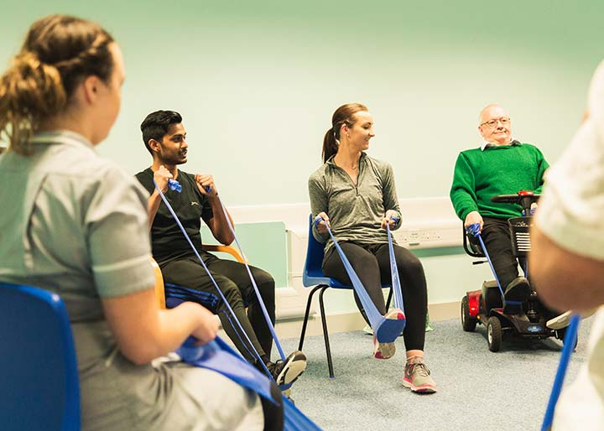

# A new and innovative way of caring for people with

# Livewell Southwest leg ulcers

## 

## Do I need to bring anything to the sessions?

## You are not required to bring anything with you for the sessions, just yourself! We would recommend bringing some water with you.

## You will be given a resistance band and an at-home guide to take away with you. Please bring these with you to all your sessions.

## Are refreshments provided?

With previous groups complimentary tea or coffees were available before or after your treatment with other Wellbeing Club members. We look forward to reinstating this in the future in line with government guidance.

## What is Leg Wellbeing Club?

Leg Wellbeing Club is a unique opportunity for you to receive information on how to manage your leg condition. Evidence suggests that leg ulcers heal faster when a healthy lifestyle is adopted.

The one-hour sessions will run once a week, for a total of 4 weeks. There will be ongoing sessions for anyone that wishes to continue after the 4 weeks.

During the sessions you will cover topics including:

* Physical activity to promote stronger healthier legs – this is seated so don’t worry if you can’t stand up for a while!
* Nutrition – how what we eat can help support faster healing.
* Sleep and sleep quality – good quality rest is helpful for a variety of conditions.

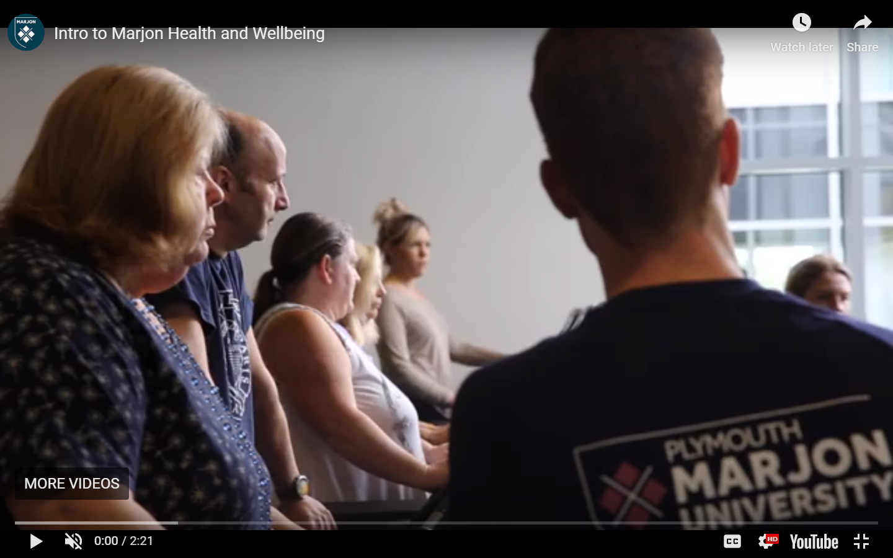

## Shared medical appointments

## What do our participants think?

Our Leg Wellbeing Clubs have been running throughout Plymouth and the South Hams for the last 4 years.

This is what some of our participants have said…

*“The group are also really supportive to each other”*

*“Extra time has been really beneficial to helping us”*

*“Nutrition/exercises all go together, it’s good”*

*“I feel happy to attend the sessions and come with a big smile on my face!”*

*“We’ve learnt from each other too”*