Prosthetics Rehabilitation Service – How to put on your prosthesis with a suspension sleeve
- Remove brown Juzo shrinker if worn
- Pull a sock on to your residual limb ensuring there are no wrinkles
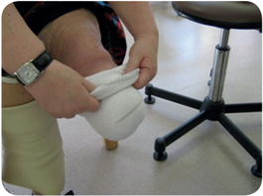
- Pull the liner on to your residual limb ensuring the patella tendon bar is over the patella tendon (just below the kneecap)
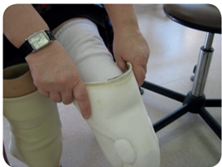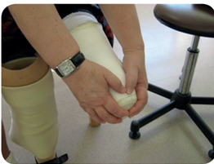

- Sit at the front of the chair. Keep the heel of the prosthesis on the floor. Tilt the leg backwards and with the knee slightly bent, push the liner and your residual limb into the socket.
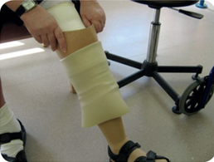

- Using the palm of your hands gently smooth the suspension sleeve up your leg ensuring that at least one inch (5cm) of sleeve is against your skin.
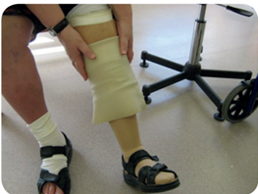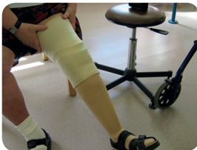

- If your socket feels too loose, add extra cotton socks. If more than one sock is work, they should be put on separately. Both thick and thin socks are available. If your socket feels tight, try a thinner cotton sock.
- If your socket is still loose with three thick socks or tight with one thin sock, contact the centre for advice.
Compliments, comments and complaints
If you’d like to compliment, comment or complain about our service please contact:
Customer Services Department
Livewell Southwest
Crownhill Court
Tailyour Road
PL6 5DH
Tel: 01752 435201
Email: customerservicespch@nhs.net

Contact details
The Thornberry Centre
1 Brest Way (off Morlaix Drive)
Derriford
Plymouth
PL6 5XW
Tel: 01752 434200
Opening times
Mon – Fri, 8:30am – 4:30pm
www.livewellsouthwest.co.uk

