Prosthetics Rehabilitation Service – How to put on your transtibial prosthesis using an Iceross liner
- Completely turn the liner inside out. If the liner does not have a cover then use talc on the outside of the liner. Do not put talc on the inside of the liner.
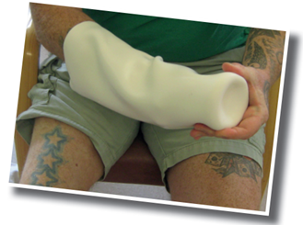
- Place the inverted liner on the end of your residual limb. Ensure there is no air trapped in the bottom. Grip the liner gently and roll onto your residual limb.
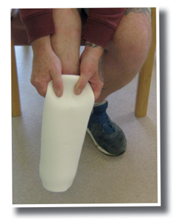

- Roll the liner completely on to your residual limb. Ensure there is no air in the liner. If there is a locking pin on the liner ensure it is straight. If socks are worn these should be applied now. Place the locking pin through the hole in the bottom of the sock. Make sure there are no wrinkles in the socks and absolutely no material on the pin.
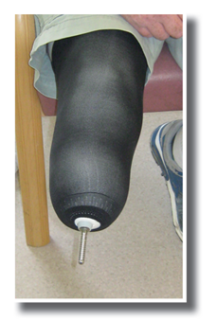
- If you have a pelite liner you should apply this first. Push your residual limb into the liner and pull the pin out of the bottom of the pelite. Slide your residual limb into the socket. Ensure your limb is at the same angle as the prosthesis. The pin must engage with the lock in the socket. Push down on the prosthesis listening for the pin clicking into the lock.
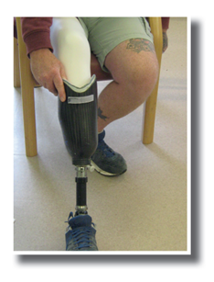
- Listen for clicks as your leg goes into the socket, ensuring the pin has engaged in the lock. Push on the prosthesis ensuring you have suspension. If suspension is secure you are ready to walk.
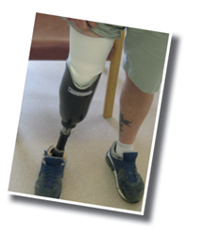
Taking your prosthesis off
- Sit down on a stable surface.
- Apply a small amount of weight on the heel of the prosthesis. Push the release button on the side of the prosthesis.
- While holding the button in, push on top of socket and lift your residual limb out of the socket.
- Take off your pelite liner and place in your prosthesis. Remove any socks to be washed.
- Pull off the liner by gently holding top of liner and sliding it down.
- Inspect skin after removing liner.
- Wash the inside of the liner daily with a mild, unscented soap. Dry your liner with a clean flannel or towel.
- Turn the liner right side out. (Never leave liner inside out).
When applying socks over your liner you must not have any sock or threads over the pin. This will jam the lock!!
If your prosthesis should jam and you cannot remove it, use warm soapy water between your skin and liner gently working your way around your residual limb to ease the liner away from your skin.
When your liner is removed try the release button on the socket to release the liner. Check around the pin area to ensure there are no loose threads.
If you cannot remove the liner from the socket contact The Thornberry Centre to arrange a workshop appointment.

